**CIRCUIT ANALYSIS  
using**

**MATLAB**

**LAB # 12**

**Spring 2023**

**CSE103L Circuits & Systems-I Lab**

Submitted by: **# MUHAMMAD UMAR**

Registration No. : **22PWCSE2148**

Class Section: **B**

“On my honor, as student of University of Engineering and Technology, I have neither given nor received unauthorized assistance on this academic work.”

Student Signature: ______________

Submitted to:

**Dr. Muniba Ashfaq**

Month Day, Year (June 10, 2023)

Department of Computer Systems Engineering

University of Engineering and Technology, Peshawar

**OBJETIVES:**

In this lab we will solve for the matrix for previous 2 labs using Matlab.

**MATLAB**

MATLAB is a high-performance language for technical computing. It integrates computation, visualization, and programming in an easy-to-use environment where problems and solutions are expressed in familiar mathematical notation. Typical uses include: Math and computation.

**SOLUTION:**

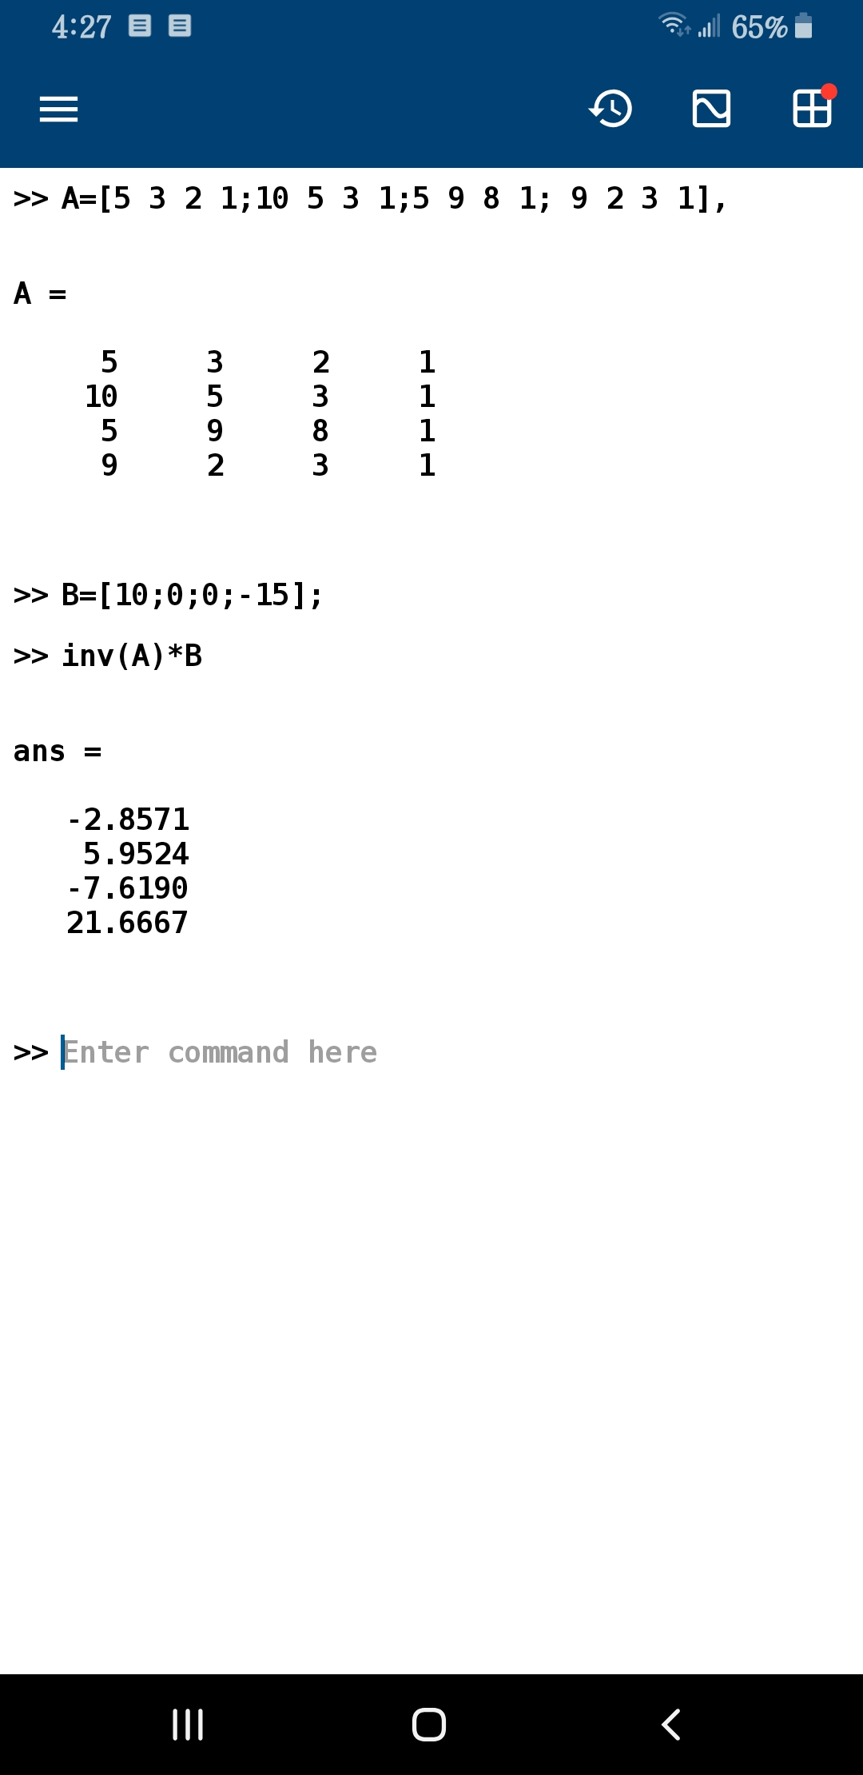

**CONCLUSION:**

We simply entered values for matrix A & B and entered a command for how to solve these matrices. We have used inverse method to solve A*B matrix and thus we found the 3 values

**LAB RUBRICS: (Circuits & Systems-I Lab)**

|  |  |  |  |  |
| --- | --- | --- | --- | --- |
| **Criteria & Point**  **Assigned** | **Outstanding**  **4** | **Acceptable**  **3** | **Considerable**  **2** | **Below Expectations**  **1** |
| **Attendance and Attentiveness in**  **Lab**  PLO10 | Attended in proper  Time and attentive in Lab | Attended in proper  Time but not attentive in Lab | Attended late but attentive in Lab | Attended late not attentive in Lab |
| **Equipment / Instruments Selection and Operation**  PLO1,  PLO2,  PLO3,  PLO5, | Right selection and operation of appropriate equipment and instruments to perform experiment. | Right selection of appropriate equipment and instruments to perform experiment but with minor issues in operation | Needs guidance for right selection of appropriate equipment and instruments to perform experiment and to overcome errors in operation | Cannot appropriately select and operate equipment and instruments to perform experiment. |
| **Result or Output/ Completion of target**  **in Lab**  PLO9, | 100% target has  been completed and well  formatted. | 75% target has been  completed and well formatted. | 50% target has  been completed but not well formatted. | None of the  outputs are  correct |
| **Overall, Knowledge**  PLO10, | Demonstrates excellent  knowledge of lab | Demonstrates good  knowledge of lab | Has partial idea about the Lab and  procedure followed | Has poor idea about the Lab and  procedure followed |
| **Attention to Lab Report**  PLO4, | Submission of Lab Report in Proper Time i.e. in next day of lab., with proper  documentation. | Submission of Lab Report in proper time but not with proper  documentation. | Late Submission  with proper  documentation. | Late Submission Very poor  documentation |